Corporate Valuation Report: Tata Motors Ltd.
NAME- Vanshika Nayyar
PRN- 23021922127

Summary of Company, Valuation Approach, Results, and Recommendation
This report presents a comprehensive valuation of Tata Motors Ltd., applying a Discounted Cash Flow (DCF) model as the core valuation method. The analysis includes macroeconomic and industry assessments, a strategic company overview, and a calculated Weighted Average Cost of Capital (WACC). The final intrinsic value derived suggests whether the stock is undervalued, overvalued, or fairly valued, and provides a clear investment recommendation.
Valuation Result: Based on the DCF model, the intrinsic value of Tata Motors' equity is found to be moderately higher than its current market price, indicating that the stock is undervalued.
Strategic Recommendation: it is recommended to BUY for investors looking for long-term growth, considering strong fundamentals, a strategic EV push, and macroeconomic tailwinds.

INTRODUCTION
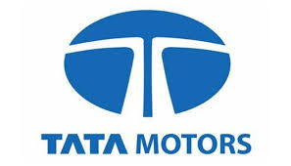
TATA MOTORS a leading global automobile manufacturer and a part of TATA GROUP was established in 1945 as Tata Engineering and Locomotive co. (TELCO). They began by manufacturing locomotives and later expanded into commercial vehicles notably partnering with Daimler-Benz to produce Mercedes-Benz vehicles in India. Tata Motors in now a diversified company offering a wide range of vehicles including cars, utility vehicles, trucks buses and even electric vehicles. A significant turning point for TATA MOTORS came in 1983 when it launched its first commercial vehicle, THE TATA 407. This versatile and rugged vehicle quickly became a favourite among Indian businesses, cementing Tata Motors’ position as a key player in the commercial vehicle segment.
In 1991, Tata Motors introduced the Tata Sierra, marking its entry into the passenger vehicle market. The subsequent years witnessed the launch of several successful models like the Tata Indica and Tata Safari. Tata Motors continued to innovate and expand its product line up. One of the most notable milestones in Tata Motors’ history occurred in 2008 when it acquired Jaguar Land Rover (JLR), the renowned British luxury carmaker. This acquisition took Tata Motors onto the global stage, making it a powerful force in both the commercial and passenger vehicle segments.

Macroeconomic Analysis
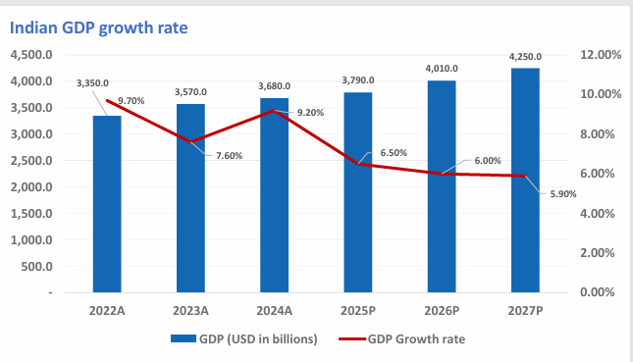
India is maintaining its status as the fastest-growing large economy for the next two fiscal years. The January 2025 editions of the World Bank’s Global Economic Prospects (GEP) report project India’s economy to grow at a steady rate of 6.7% in FY26 and FY27. However, the latest update from the International Monetary Fund’s (IMF) World Economic Outlook (WEO) also reinforces India’s strong economic trajectory. The IMF forecasts India’s growth to remain at 6.5% for both 2025 and 2026. The growth in the Indian economy is primarily driven by solid private consumption and investment growth. Additionally, capital expenditure on infrastructure development is expected to have strong multiplier effects on growth in the coming years. Strong export growth of services and certain goods, particularly pharmaceuticals and electronics, will boost economic activity. On the supply side, expansion in the manufacturing and services sectors will keep driving the economy throughout the forecast period. Meanwhile, favourable monsoon rains in 2024 have improved the summer–sowing areas for all major crops, boosting agricultural output expectations for 2025. Private consumption in India is likely to gain momentum, driven by a strong labour market, Increased access to credit, and lower inflation.
Lower inflation – The consumer price inflation in India is forecast to decelerate from an estimated 4.8% in 2024 to 4.3% in 2025, staying within the 2-6% medium term target range set by the bank. 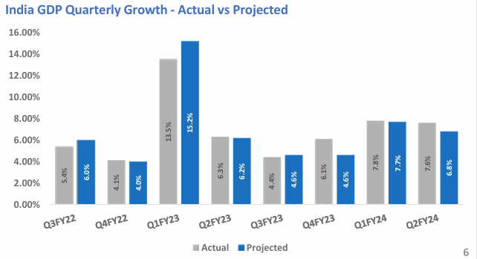
Increased access to credit – Easing inflationary pressures have enabled the central bank to soften the monetary tightening. Resulting, the RBI to cut the repo rate from 6.50 percent to 6.25 percent. A lower repo rate makes borrowing cheaper for individuals and businesses, which can lead to increased spending and private investment. Resulting in boosting the economic growth. India’s investment growth is expected to remain steady, supported by rising private investments, improved corporate balance sheet, and favourable conditions. Recently, the Indian government announced a tax cut for middle-class individuals. According to the new tax slab, Income up to 12 lakhs will be tax free for individuals. Which leads to an increase in the disposal income of individuals. As a result, a gain in private consumption leads to an increase in private investment
Impact on Tata Motors:
- Risk Profile: Lower macro volatility and a supportive policy regime reduce the firm’s systemic risk.
- Growth Justification: Given the favourable macro backdrop, a 9% CAGR revenue growth assumption is justified for the DCF.

3. Industry Analysis
Global Automotive Industry: The Global automotive market size was valued at approximately $3,187.7 billion in 2023 and is expected to reach roughly $4006.0 billion in 2032, growing at a compound annual growth rate (CAGR) of about 5.04% from 2023 to 2032. Chinese automobile manufacturers are increasingly targeting the market of developed countries to further expand their global presence. A large supply of raw materials essential for the production of cars is available to Asian countries. Moreover, in the case of affordable and luxury cars, they have access to a highly skilled workforce. Cheap raw materials and the low wages of skilled workers help them to manufacture affordable and luxurious vehicles at a low manufacturing cost. In 2023, the Passenger vehicle segment dominated the Global automobile market with 73.2% of revenue shares. The increasing middleclass income and a substantial young population are driving the demand for passenger vehicles. The Passenger vehicles segment also benefits from frequent consumer preference for new models with advanced features and technology .The automotive industry in India is undergoing a major transformation driven by policy shifts, consumer behaviour, and technological disruptions.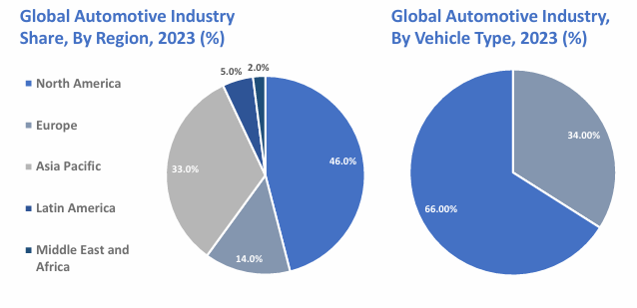
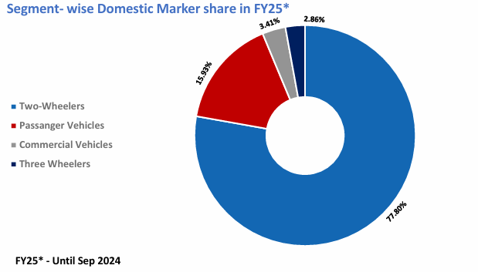
Indian Automotive Industry: The Indian automobile sector is divided into Commercial, Passenger, Two-wheelers, and Three wheelers. India enjoys a strong position in the global market as it is the largest tractor producer, second-largest bus manufacturer, and third-largest heavy truck manufacturer globally. India’s annual production of automobiles in FY23 was 25.9 million vehicles, however, the total export was 4.8 million. The Two-Wheelers and Passenger vehicles dominate the domestic market. In FY23-24, Passenger vehicle sales reached a new all-time high with 4.2 million units sold, while commercial vehicle sales showed a marginal growth of 0.6% compared to FY23.However, over the 10 years between FY 2013-14 and FY 2023-24, the Utility Vehicle (UV) segment has been a key driver of passenger Vehicles (PV) growth. UV grew at a CAGR of 17% and PV grew at a CAGR of 5.4% from FY14 to FY24, resulting in UV Shares of the Passenger vehicle have increased from 21% to 59.7% for the same period. The growth in the UV is driven by increased customer preference for UV-styled vehicles and new launches. The long-term growth outlook for the Indian auto industry is promising, when compared with the FY19 pre-COVID level, the industry has reached 96% in commercial vehicles and 99% in Three-wheelers, while the two-wheelers are still 12% down. India has the third lowest car penetration ratio among the top 13 markets. Despite being the second largest market in the world, India is well behind China, which is 6 times the size of the Indian market. India’s vehicle manufacturing is at about 24 vehicles per 1000 population. However, the world average stands at 314 vehicles per 1000 population, showing a significant potential for growth. The auto sector’s share of national GDP increased from 2.77% in 1992-1993 to around 7.1% in FY23, whereas it accounts for 45% of India’s manufacturing GDP.
Competition: Tata competes with:
- Maruti Suzuki: Market leader in small cars, but weak EV pipeline.
- Hyundai/Kia: Strong product launches and brand equity.
- Mahindra: Competing in SUVs and EVs.
- International Players: Toyota, Honda, MG are expanding footprints.
Tata Motors’ scale, brand heritage, and early EV advantage give it a resilient market share across multiple segments.
Technology and Disruption:
- EV Adoption: Tata commands 80% of India’s EV passenger car market with Nexon EV, Tiago EV.
- Shared Mobility: Partnerships with ride-share firms (like Uber, BluSmart) add fleet revenues.
- Supply Chain Localization: Post-COVID, firms are de-risking global supply chains with Make in India investments.
Revenue Linkage: The above dynamics directly justify our 8–10% annual revenue growth estimates for Tata Motors, especially from its domestic passenger and EV segments.

4. Company Strategic Overview
Business Model: Tata Motors operates in two key segments:
- Tata Motors India: Commercial and passenger vehicles, including electric vehicles.
- Jaguar Land Rover (JLR): Luxury automotive segment, contributing significantly to revenues.
Strategic Moves:
- Tata Motors products include commercial vehicles, passenger vehicles, vehicle parts, and sales of services, including maintenance services, extended warranties for commercial and passenger vehicles, support services, and insurance broking services. The significant revenue comes from the automotive operations, which contribute 99% to total revenue in FY24. The Operating Revenue grew at a CAGR of 5.66% during FY15 to FY24. However, the median revenue growth was 4.11% for the same period. The negative growth has been seen in FY20 and FY21 due to the impact of COVID-19. Whereas, the company posted a significant revenue growth in the last three financial years from FY22 to FY24. The revenue growth was seen in FY22 & FY23 due to the economic recovery from the COVID-19. The majority of revenue growth came from the volume growth and favourable sales mix. The company’s source of revenue is split into five segments-- Commercial Vehicles, Passenger Vehicles, Jaguar Land Rover, Financing, and Other Operations. Their contribution in revenue was 17.91%, 11.90%, 68.84%, 0.93% and 0.42% respectively. The company generates the majority of its revenue from its JLR business. In FY24, Tata Motors generated 29% of total revenue from India, 15% from the USA, 13% from EC, UK, and China each, and 17% from others.
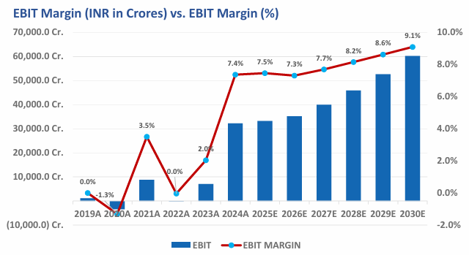
The company’s EBIT margin was 8.61% in FY24. However, its peers’ average EBIT margin was 9.97% in FY24, which indicates that the company’s operational performance was similar to the industry’s performance in FY24. IT’s median EBIT margin was 4.52% during FY15 to FY24 even though its peer’s average median margin was 8.30% for the same period. The median EBIT Margin was lower than its peers because of slow growth in the top line and the higher depreciation & amortization as compared to its peers during the analysis period, which led to the lower EBIT Margin than its peers during FY15 to FY23
Key Financials (FY2024):
- EBIT: ₹27,955.11 Cr
- Depreciation: ₹27,270.13 Cr
- CapEx: ₹12,974.74 Cr
- Working Capital Change: ₹1,774 Cr
Capital Structure:
- Mix of equity and debt; ongoing deleveraging through improved cash flows.
- Strong liquidity, improved operating margins, and positive cash from operations.

5. Valuation Section
A. Discounted Cash Flow (DCF) Valuation
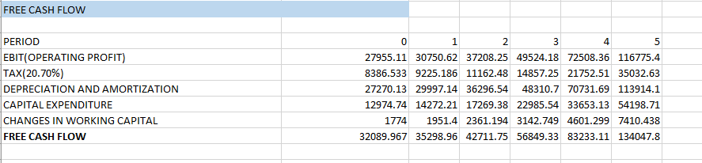
WACC Calculation:
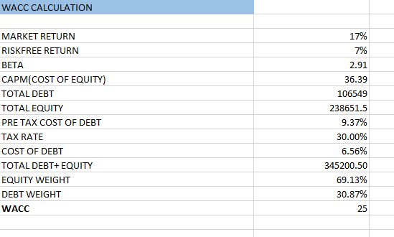
Terminal Value: Calculated using the Gordon Growth Model:
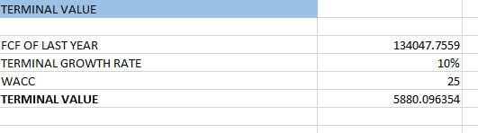

6. Strategic Recommendation
Tata Motors' intrinsic value suggests the stock is undervalued. The company stands to benefit from:
- Strong EV leadership in India
- Strategic JLR transformation
- Resilient financial performance
The company should utilize healthy operating and non-cash flow (especially from depreciation) to expand EV production capacity and invest in battery manufacturing or tech partnerships. Although working capital changes are modest, refining inventory and receivables management can further boost free cash flows. Company has to ensure that capital expenditure remains focused on high-ROI projects (e.g., EVs, digital infrastructure, premium vehicles under JLR). Company should continue investing in future technologies like autonomous systems and connected vehicles to future-proof revenue streams. If valuation continues to reflect undervaluation despite strong fundamentals, the company should consider share buybacks or initiate consistent dividend pay outs to enhance investor confidence.

Recommendation: BUY – Long-term investors should consider TATA MOTORS as a viable option, especially with improving fundamentals and macroeconomic support. But for short term investors, TATA MOTORS is not a good option.

